EE211 Fall 2025
Homework - Problem Set #6

Due: December 8th, 11:59 pm
Please scan your homework and upload it on the KLMS website.

Problem 1 (10 points)
A Si step junction maintained at room temperature under equilibrium conditions has a p-side doping of N_{A} = 2×10¹⁵ cm⁻³ and n-side doping of N_{D} = 10¹⁵ cm⁻³. Compute (a) V_{bi} , (b) x_{p}, x_{n}, and W, (c) E at x = 0, and (d) V at x = 0. (e) Make sketches that are roughly to scale of the charge density, electric field and electrostatic potential as a function of position.

<Solution>
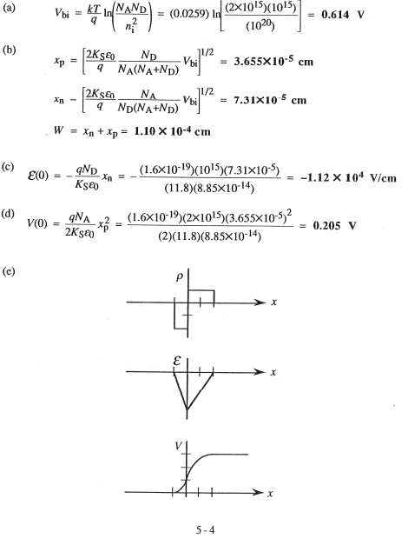

Problem 2 (10 points)
Repeat Problem 1, taking N_{A} = 10¹⁷ cm⁻³ to be the p-side doping. Briefly compare the results here with those of Problem 1.

<Solution>
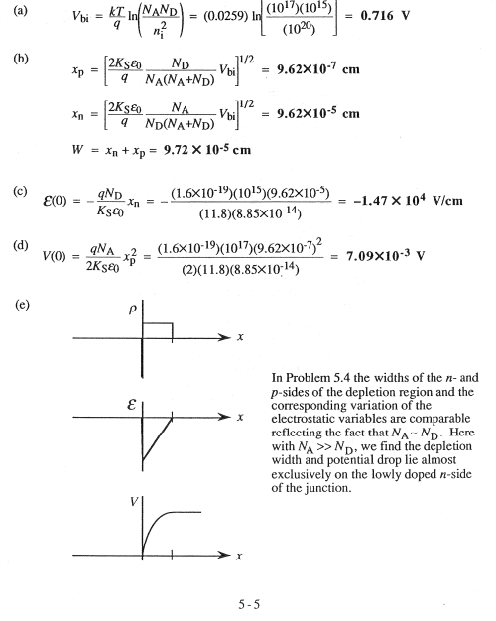

Problem 3 (10 points)
A pn junction diode has the doping profile sketched as below. Mathematically, N_{D}-N_{A} = N₀[1-exp(-αx)], where N₀ and α are constants. (a) Give a concise statement of the depletion approximation. (b) Invoking the depletion approximation, make a sketch of the charge density inside the diode. (c) Establish an expression for the electric field E(x), inside the depletion region.

<Solution>

Problem 4 (10 points)
A pn junction diode has the doping profile sketched as below. Assume that x_{n} > x₀. (a) What is the built-in potential across the junction? (b) Invoking the depletion approximation, sketch the charge density versus distance inside the diode. (c) Obtain an analytical solution for the electric field, E(x), inside the depletion region.
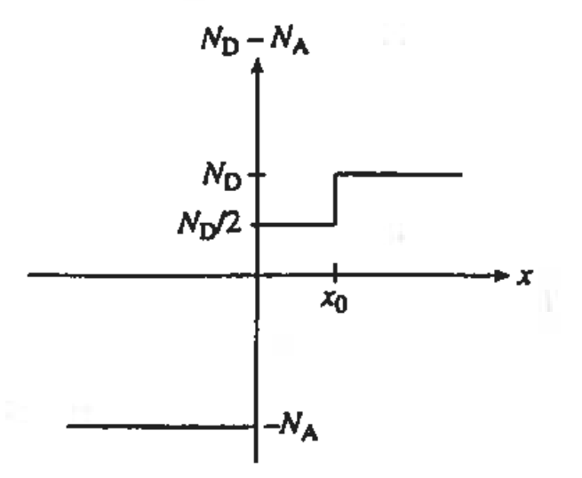

<Solution>
(a)
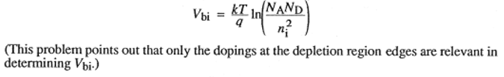

(b)
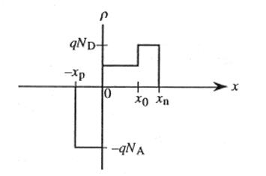

(c)
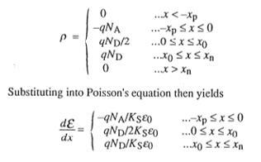

Problem 5 (10 points)
An “isotype” step junction is one in which the same impurity type doping changes from one concentration value to another value. A p-p isotype doping profile is shown as follows. (a) Sketch the thermal equilibrium energy-band diagram of the isotype junction. (b) Determine the built-in potential barrier. (c) Make rough sketches of the potential, electric field, and charge density inside the junction.
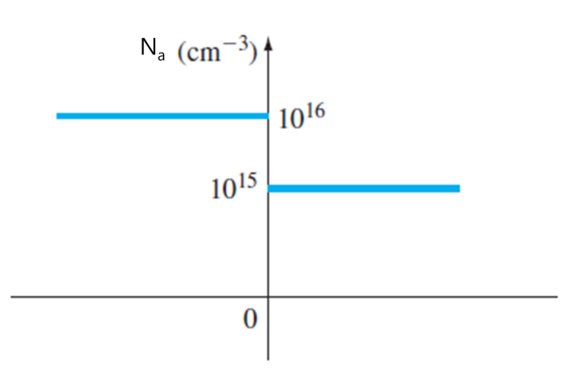

<Solution>
(a)
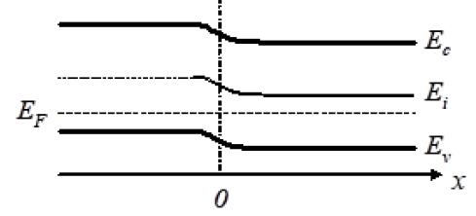

(b)
For N_{a} =10¹⁶ cm⁻³,
$$E_{F}-E_{Fi}=kTln\left(\frac{N_{a}}{n_{i}}\right)=\left(0.0259\right)ln\left(\frac{{10}^{16}}{1.5×{10}^{10}}\right)$$
$$or$$
$$E_{F}-E_{Fi}=0.3473 eV$$

For N_{a} =10¹⁵ cm⁻³,
$$E_{F}-E_{Fi}=\left(0.0259\right)ln\left(\frac{{10}^{15}}{1.5×{10}^{10}}\right)$$
$$or$$
$$E_{F}-E_{Fi}=0.2877 eV$$

Then,
$$V_{bi}=0.34732-0.28768$$
$$or$$
$$V_{bi}=0.0596 V$$

(c)
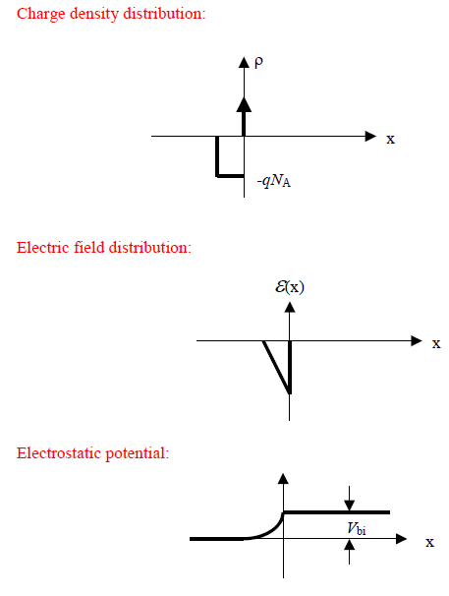

Problem 6 (10 points)
An abrupt silicon pn junction at T = 300 K has impurity doping concentrations of N_{A} = 5×10¹⁶ cm⁻³ and N_{D} = 10¹⁵ cm⁻³. Calculate (a) V_{bi}, (b) W at (i) V_{R} = 0 and (ii) V_{R} = 5 V, and (c) |E_{max}| at (i) V_{R} = 0 and (ii) V_{R} = 5V.

<Solution>
(a)
$$V_{bi}=\left(0.0259\right)ln\left[\frac{(5×{10}^{16})({10}^{15})}{{(1.5×{10}^{10})}^{2}}\right]=0.6767V$$

(b)
$$W= {\left\{\frac{2∈_{s}{(V}_{bi}+V_{R})}{e}\right.\left.\left(\frac{N_{a}+N_{d}}{N_{a}N_{d}}\right)\right\}}^{1/2}$$
(i) For V_{R}=0,
$$W= {\left\{\frac{2(11.7)(8.85×{10}^{-14})(0.6767)}{1.6×{10}^{-19}}×\right.\left.\left[\frac{5×{10}^{16}+{10}^{15}}{(5×{10}^{16})({10}^{15})}\right]\right\}}^{1/2}$$
$$=9.452×{10}^{-5} cm$$
$$or$$
$$W=0.9452 μm$$

(ii) For V_{R}=5V,
$$W= {\left\{\frac{2(11.7)(8.85×{10}^{-14})(0.6767+5)}{1.6×{10}^{-19}}×\right.\left.\left[\frac{5×{10}^{16}+{10}^{15}}{(5×{10}^{16})({10}^{15})}\right]\right\}}^{1/2}$$
$$=2.738×{10}^{-4} cm$$
$$or$$
$$W=2.738 μm$$

(c)
$$\left|E_{max}\right|=\frac{2(V_{bi}+V_{R})}{W}$$
(i) For V_{R}=0,
$$\left|E_{max}\right|=\frac{2(0.6767)}{0.9452×{10}^{-4}}=1.43×{10}^{4} V/cm$$

(ii) For V_{R}=5V,
$$\left|E_{max}\right|=\frac{2(0.6767+5)}{2.738×{10}^{-4}}=4.15×{10}^{4} V/cm$$

Problem 7 (10 points)
Consider two p⁺n silicon junctions at T = 300 K reverse biased at V_{R} = 5 V. The impurity doping concentrations in junction A are N_{A} = 10¹⁸ cm⁻³ and N_{D} = 10¹⁵ cm⁻³, and those in junction B are N_{A} = 10¹⁸ cm⁻³ and N_{D} = 10¹⁶ cm⁻³. Calculate the ratio of the following parameters for junction A to junction B: (a) W, (b) |E_{max}|, and (c) C’_{j}.

<Solution>
(a)
$$\frac{W(A)}{W(B)}=\frac{{\left\{\frac{2∈_{s}{(V}_{biA}+V_{R})}{e}\right.\left.\left(\frac{N_{a}+N_{dA}}{N_{a}N_{dA}}\right)\right\}}^{1/2}}{{\left\{\frac{2∈_{s}{(V}_{biB}+V_{R})}{e}\right.\left.\left(\frac{N_{a}+N_{dA}}{N_{a}N_{dB}}\right)\right\}}^{1/2}}$$
$$or$$
$$\frac{W(A)}{W(B)}={\left[\frac{{(V}_{biA}+V_{R})}{{(V}_{biB}+V_{R})}\frac{(N_{a}+N_{dA})}{(N_{a}+N_{dB})}\left(\frac{N_{dB}}{N_{dA}}\right)\right]}^{1/2}$$
We find
$$V_{biA}= \left(0.0259\right)ln\left[\frac{({10}^{18})({10}^{15})}{{(1.5×{10}^{10})}^{2}}\right]=0.7543V$$
$$V_{biB}= \left(0.0259\right)ln\left[\frac{({10}^{18})({10}^{16})}{{(1.5×{10}^{10})}^{2}}\right]=0.8139V$$
We find
$$\frac{W(A)}{W(B)}={\left[\left(\frac{5.7543}{5.8139}\right)\left(\frac{{10}^{18}+{10}^{15}}{{10}^{18}+{10}^{16}}\right)×\left(\frac{{10}^{16}}{{10}^{15}}\right)\right]}^{1/2}$$
$$or$$
$$\frac{W(A)}{W(B)}=3.13$$

(b)
$$\frac{E(A)}{E(B)}=\frac{\frac{2(V_{biA}+V_{R})}{W(A)}}{\frac{2(V_{biB}+V_{R})}{W(B)}}=\frac{W(B)}{W(A)}∙\frac{V_{biA}+V_{R}}{V_{biB}+V_{R}}=\left(\frac{1}{3.13}\right)\left(\frac{5.7543}{5.8139}\right)$$
$$or$$
$$\frac{E(A)}{E(B)}=0.316$$

(c)
$$\frac{{C'}_{j}(A)}{{C'}_{j}(B)}=\frac{{\left[\frac{∈_{s}N_{a}N_{dA}}{2(V_{biA}+V_{R})(N_{a}+N_{dA})}\right]}^{1/2}}{{\left[\frac{∈_{s}N_{a}N_{dB}}{2(V_{biB}+V_{R})(N_{a}+N_{dB})}\right]}^{1/2}}={\left[\left(\frac{N_{dA}}{N_{dB}}\right)\left(\frac{V_{biB}+V_{R}}{V_{biA}+V_{R}}\right)\left(\frac{N_{a}+N_{dB}}{N_{a}+N_{dA}}\right)\right]}^{1/2}={\left[\left(\frac{{10}^{15}}{{10}^{16}}\right)\left(\frac{5.8139}{5.7543}\right)\left(\frac{{10}^{18}+{10}^{16}}{{10}^{18}+{10}^{15}}\right)\right]}^{1/2}$$
$$or$$
$$\frac{{C'}_{j}(A)}{{C'}_{j}(B)}=0.319$$

Problem 8 (10 points)
Consider a silicon pn junction with the doping profile shown in the figure below. T = 300 K. (a) Calculate the applied reverse-biased voltage (V_{R}) required so that the space charge region extends entirely through the p region. (b) Determine the space charge width into the n⁺ region with V_{R} calculated in part (a). (c) Calculate the peak electric field for this applied voltage.
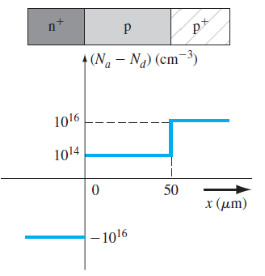

<Solution>
An n⁺p junction with N_{a} = 10¹⁴ cm⁻³,
(a)
A one-sided junction and assume V_{R} >> V_{bi}.
Then,
$$x_{p}≅ {\left[\frac{2∈_{s}V_{R}}{eN_{a}}\right]}^{1/2}$$
$$or$$
$${\left(50×{10}^{-4}\right)}^{2}=\frac{2\left(11.7\right)\left(8.85×{10}^{-14}\right)V_{R}}{\left(1.6×{10}^{-19}\right)\left({10}^{14}\right)}$$
which yields
$$V_{R}=193 V$$

(b)
$$\frac{x_{p}}{x_{n}}=\frac{N_{d}}{N_{a}}⟹x_{n}=x_{p}\left(\frac{N_{a}}{N_{d}}\right)$$
so
$$x_{n}=\left(50×{10}^{-4}\right)\left(\frac{{10}^{14}}{{10}^{16}}\right)=0.50×{10}^{-4}cm=0.50μm$$
(c)
$$\left|E_{max}\right|≅\frac{2V_{R}}{W}=\frac{2\left(193.15\right)}{50.5×{10}^{-4}}$$
$$or$$
$$\left|E_{max}\right|=7.65×{10}^{4} V/cm$$

Problem 9 (10 points)
A diode will very often have the doping profile shown in the figure in Problem 8, which is known as an n⁺pp⁺ diode. Under reverse bias, the depletion region must remain within the p-region to avoid premature breakdown. Assume the p-region doping is 10¹⁵ cm⁻³. Determine the reverse-biased voltage such that the depletion region remains within the p region and does not reach breakdown if the p-region width is (a) 75 μm and (b) 150 μm. Refer to the figure below, state whether the maximum depletion width or the breakdown voltage is reached first for each case.
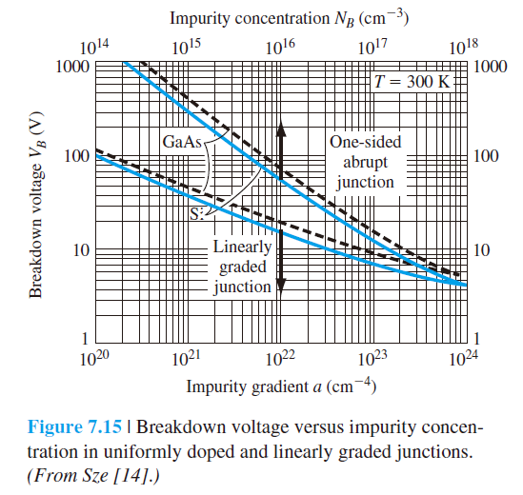

<Solution>
Assume silicon: For an n⁺p junction
$$x_{p}= {\left[\frac{2∈_{s}({V_{bi}+V}_{R})}{eN_{a}}\right]}^{1/2}$$
Assume V_{bi} << V_{R}
(a)
For $x_{p}=75μm$
$${(75×{10}^{-4})}^{2}=\frac{2(11.7)(8.85×{10}^{-14})V_{R}}{(1.6×{10}^{-19})({10}^{15})}$$
Which yields
V_{R} = 4.35$×{10}^{3} V$

(b)
For $x_{p}=150μm$
$${(150×{10}^{-4})}^{2}=\frac{2(11.7)(8.85×{10}^{-14})V_{R}}{(1.6×{10}^{-19})({10}^{15})}$$
which yields
V_{R} = 1.74$×{10}^{4} V$
Note: From Figure 7.15, the breakdown voltage is approximately 300V. So, in each case, breakdown is reached first.

Problem 10 (10 points)
A silicon p-i-n junction has the doping profile shown in the figure below. The ‘i’ corresponds to an ideal intrinsic region in which there is no impurity doping concentration. (a) Draw charge, electric field, and potential briefly. (b) Determine V_{bi}, x_{p}, x_{n}, and E_{max}.

<Solution>
(a)
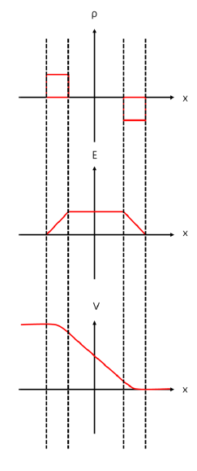

(b)
